1. **SCOPE**

The purpose for this SOP is to provide instructions for the use of the CSSP Report Writer Helper application to create special table templates (a.k.a salinity, temperature and table 3: fecal coliform densities) for report purposes. Note that Table 1 of reports (Statistics of fecal coliform densities) is included in the ‘CSSP Report Writer Helper application document’ SOP.

1. **REFERENCES**

CSSP Webtools: <http://wmon01dtchlebl2/>

CSSP Report Writer Helper application documents

1. **PROCEDURE**

3.1. Install the CSSP Report Writer Helper application found here:

\\Atlantic.int.ec.gc.ca\shares\Branches\EPB\ShellFish\CSSP_Code\CSSPReportWriterHelper_Install

Or

\\int.ec.gc.ca\SHARES\M\MQEM_NATIONAL\CSSP_Code\latest\CSSPReportWriterHelper_Install

If this is the first time you use the application, please read the ‘CSSP Report Write Helper application SOP in order to familiarize yourself with the application.

3.2 Creating Table 3 of reports: Fecal coliform densities – step by step

In this example, we will create a template to generate a report that has all fecal coliform density information for all active sampling stations of a specific subsector (e.i. Table 3 of reports)

The level required in this example would be **Subsector.** So remember that Webtools must be in a subsector to allow the search to work properly. If Webtools is at an Area or a Sector, an error will occur with your template.

* Click on the ‘**Show Web’** button to view Webtools :<http://wmon01dtchlebl2/csspwebtools/>
* Navigate to any Subsector level information ex: NB-06-020-002
* Click on the ‘**Get ID’; 635** appears in the text box and the written description next to it.
* Click on ‘**Hide Web’** to return to the CSSPReportWriterHelper app
* Select your language
* Indicate the ‘**Maximum number of items’** to be returned in you template results. Type in 5.
* Select the template type you would like to create**; Word.**
* You can create a template file by clicking on the **‘create’** button.
* Next you can select the data you want to query by checking each box beside the data title. You can expand the fields or close them by selecting the radio button. If you want to restart your selection you can clear previously selected fields.
* In our example, you would scroll down to ‘Subsector_Fields’ and select the ‘+’ box to expand the dataset. Select ‘Subsector_Name_Long’ (check box) and then click on the GREEN SUBSECTOR (you will see the information added on the middle right screen).
* Next you would scroll down and expand ‘Subsector_Special_Table_Fields’.
* Now you need to continue checking the desired boxes. Go back in the ‘Subsector_Special_Table_Fields ’list and check the;

Subsector_Special_Table_Error

Subsector_Special_Table_Last_X_Runs EQUAL 30

Subsector_Special_Table_Type EQUAL FCDensitiesTable

Subsector_Special_Table_MWQM_Site_Is_Active TRUE

Subsector_Special_Table_Number_Of_Samples_For_Stat_Max EQUAL 30

Subsector_Special_Table_Number_Of_Samples_For_Stat_Min EQUAL 10

Subsector_Special_Table_Highlight_Above_Min_Number EQUAL 43

Subsector_Special_Table_Highlight_Below_Max_Number EQUAL 30000

Subsector_Special_Table_Show_Number_Of_Days_Of_Precipitation EQUAL 3

Subsector_Special_Table_Max_Number_Of_Sites_Per_Table_Part EQUAL 500

The text in blue represents filtering options you need to select for each. For example, the first one ‘Subsector_Special_Table_Last_X_Runs EQUAL 30’: After you have checked this box, you need to click on the ‘Subsector_Special_Table_Last_X_

Runs’ name (don’t uncheck it) and then on the top right corner select under ‘Database Filtering’ ‘EQUAL’ from the drop box and then type in 30 on the next box over. If you select a very large number (example 50000), the table will include all the runs.

The Subsector_Special_Table_MWQM_Site_Is_Active TRUE will show only active sites, FALSE would show only inactive sites and no filtering here would show all sites.

Notes on the other boxes: The ‘Subsector_Special_Table_Error’ is a feature that helps Charles debug it there are any errors. It is not obligatory for the table creation but helps Charles.

The Subsector_Special_Table_Highlight_Below_Max_Number EQUAL 30000 is there in case you would want to only highlight a specific range. Seeing as in this example we want to highlight anything above 43, we put the Max_Number very high.

For the ‘Subsector_Special_Table_Show_Number_Of_Days_Of_Precipitation’, you can either put 0 and have no rain included in the table or you can go up to 5 days.

Lastly the Subsector_Special_Table_Max_Number_Of_Sites_Per_Table_Part EQUAL 500 is set at 500 because we typicly want to see all the sampling sites in one table so we picked a number that we are sure is high enough to get all the sampling stations in.

* Next click on the on the GREEN SUBSECTOR (you will see the information added on the middle right screen).
* Next click on the ‘Open button’ (make you sure have selected the template that you named at the start.) Copy and Paste all the text/code from the middle right column into your **word document**. Once you are done, it should look like bellow:

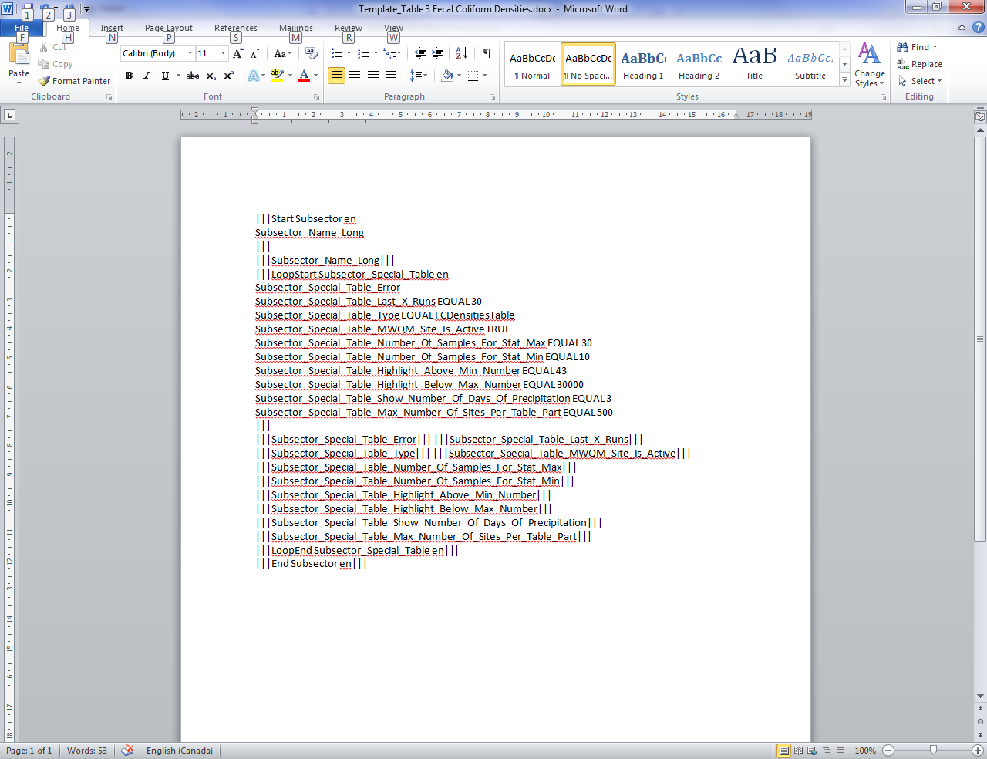

* Next you need to delete the bellow highlighted section because it will not be needed for the template (the information will still be pulled from the database):

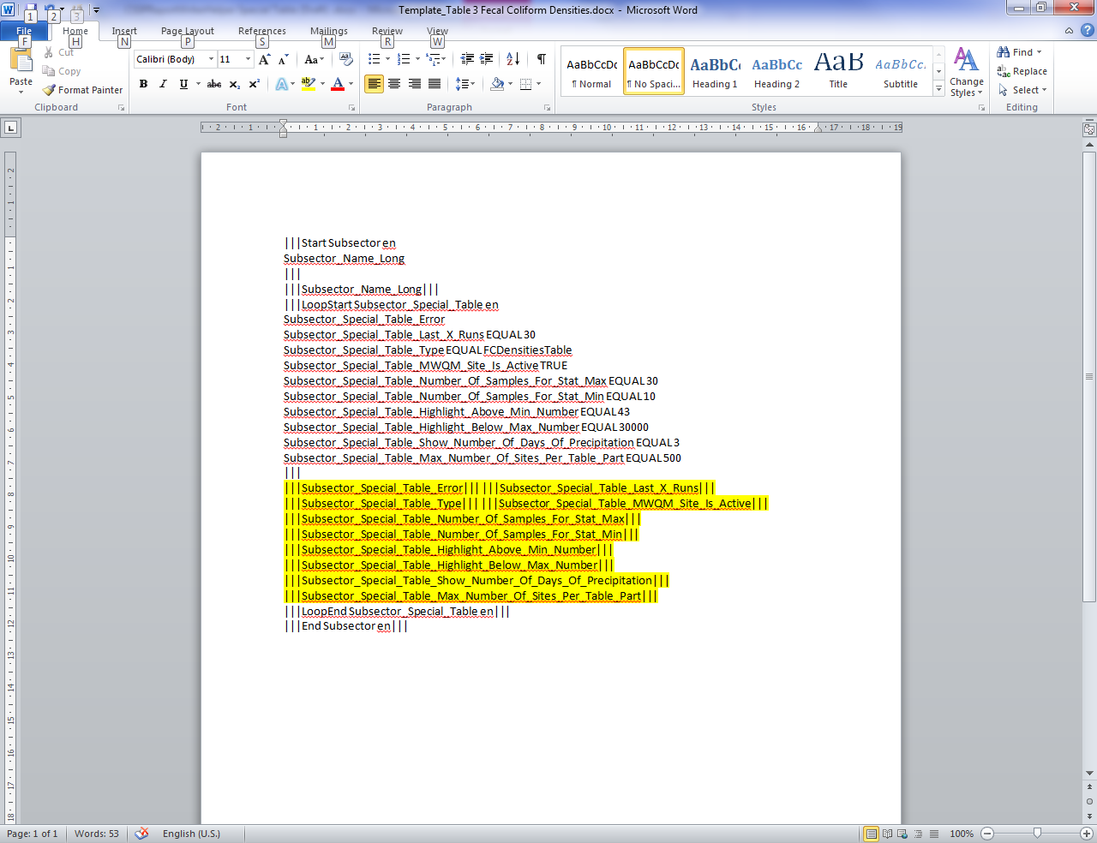

* Instead of the yellow section, you need to type in the title of the table (see yellow section below).

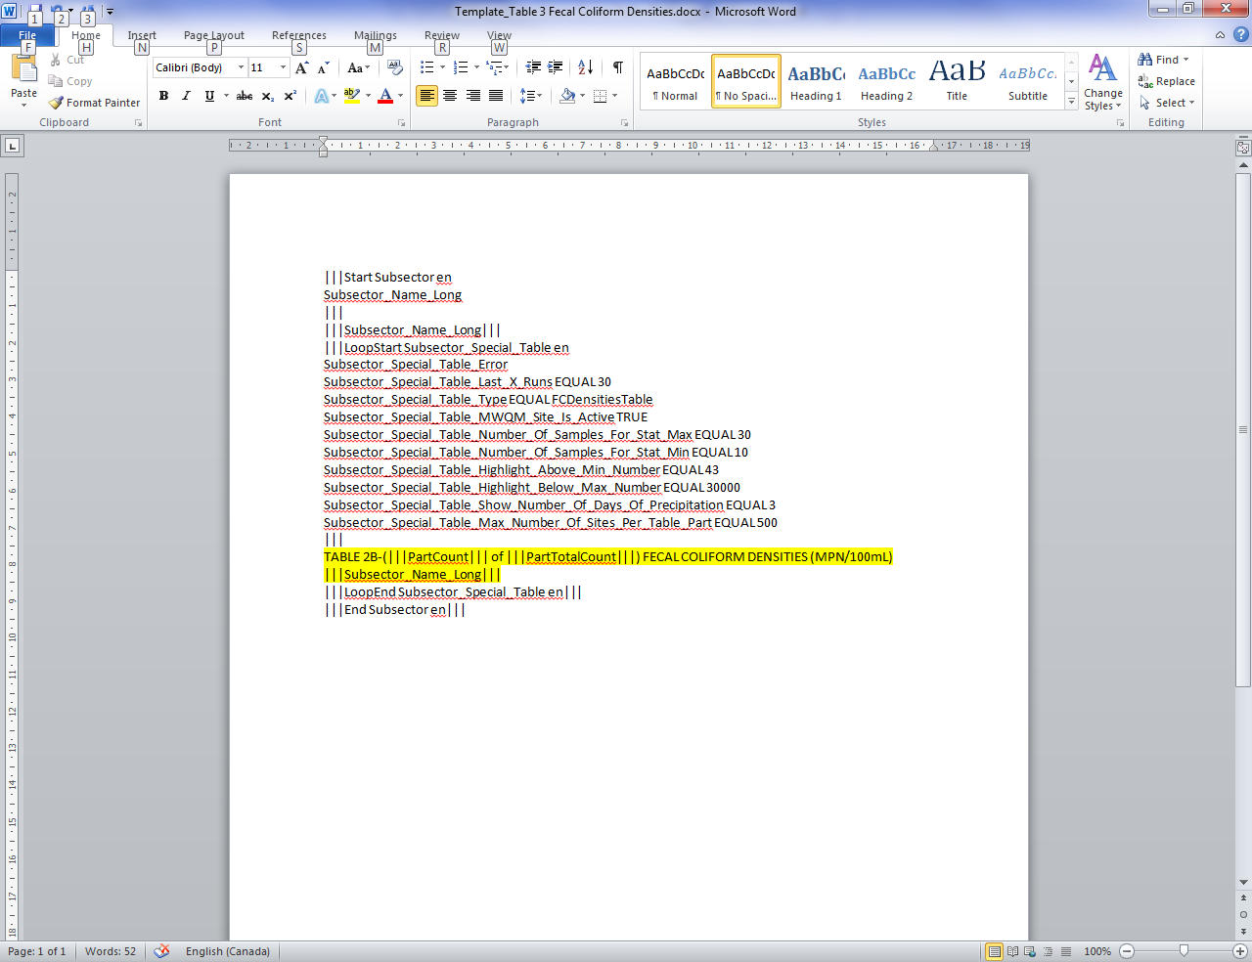

* Save this (without any highlighted sections). All template files are automatically stored in C:\CSSPReportTemplates\ directory.
* Now is a good time to test your template in the application to make sure there are no errors. Go back in the application and select your template from the drop down list and click on ‘Test Selected Template’ (make sure you have selected an ID on the top right). A word document will open and you table will be populated. NOTE: THIS WILL TAKE SOME TIME, LET THE DOCUMENT DO IT’S THING, CHARLES WILL WORK ON A WAY TO MAKE THIS GO FASTER.
* Your table should look like:

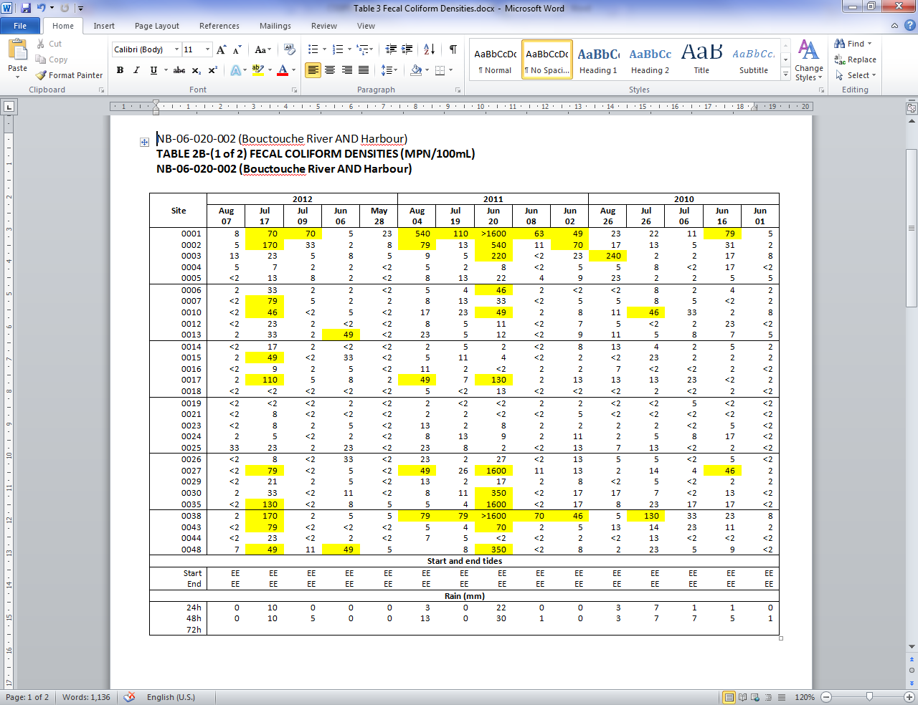

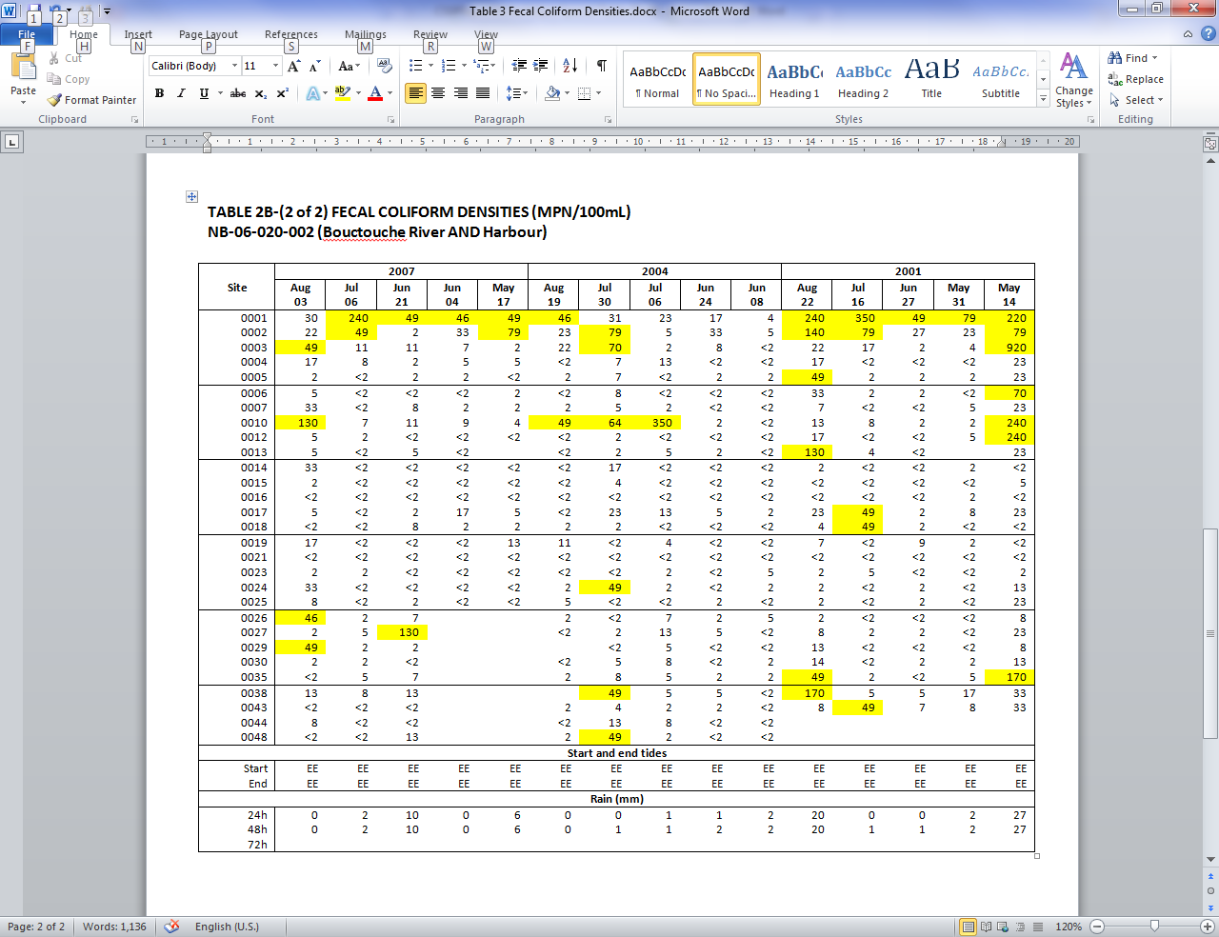

* Note: you can remove the extra title on top. Also, the tides are showing up as ‘EE’, this will be fixed with the correct information in the future.
* You can now upload the template created to any Subsector page by using the File tab in the webtools. See section 3.3.
* Once the template is uploaded for one particular subsector, all other subsectors will have access to the same template.

3.3 Importing templates into CSSP Webtools

Once you have completed a template you will need to import it into the CSSP Webtools in order to generate reports. Once a template is uploaded, it can be used by all users to generate reports.

3.3.1 Open CSSPWebtools and navigate to the database level that you were in when you created the template (i.e. Subsector). This is very important. You must import the template in the file tab of the appropriate level. Example: If your template is for a report showing all tide stations for each **province**, then you need to upload the template under the **‘File tab’ of a specific province**. The template will then be available for all provinces.

3.3.2 Click on the edit button and then on the add button  to open the Upload File section as shown below:

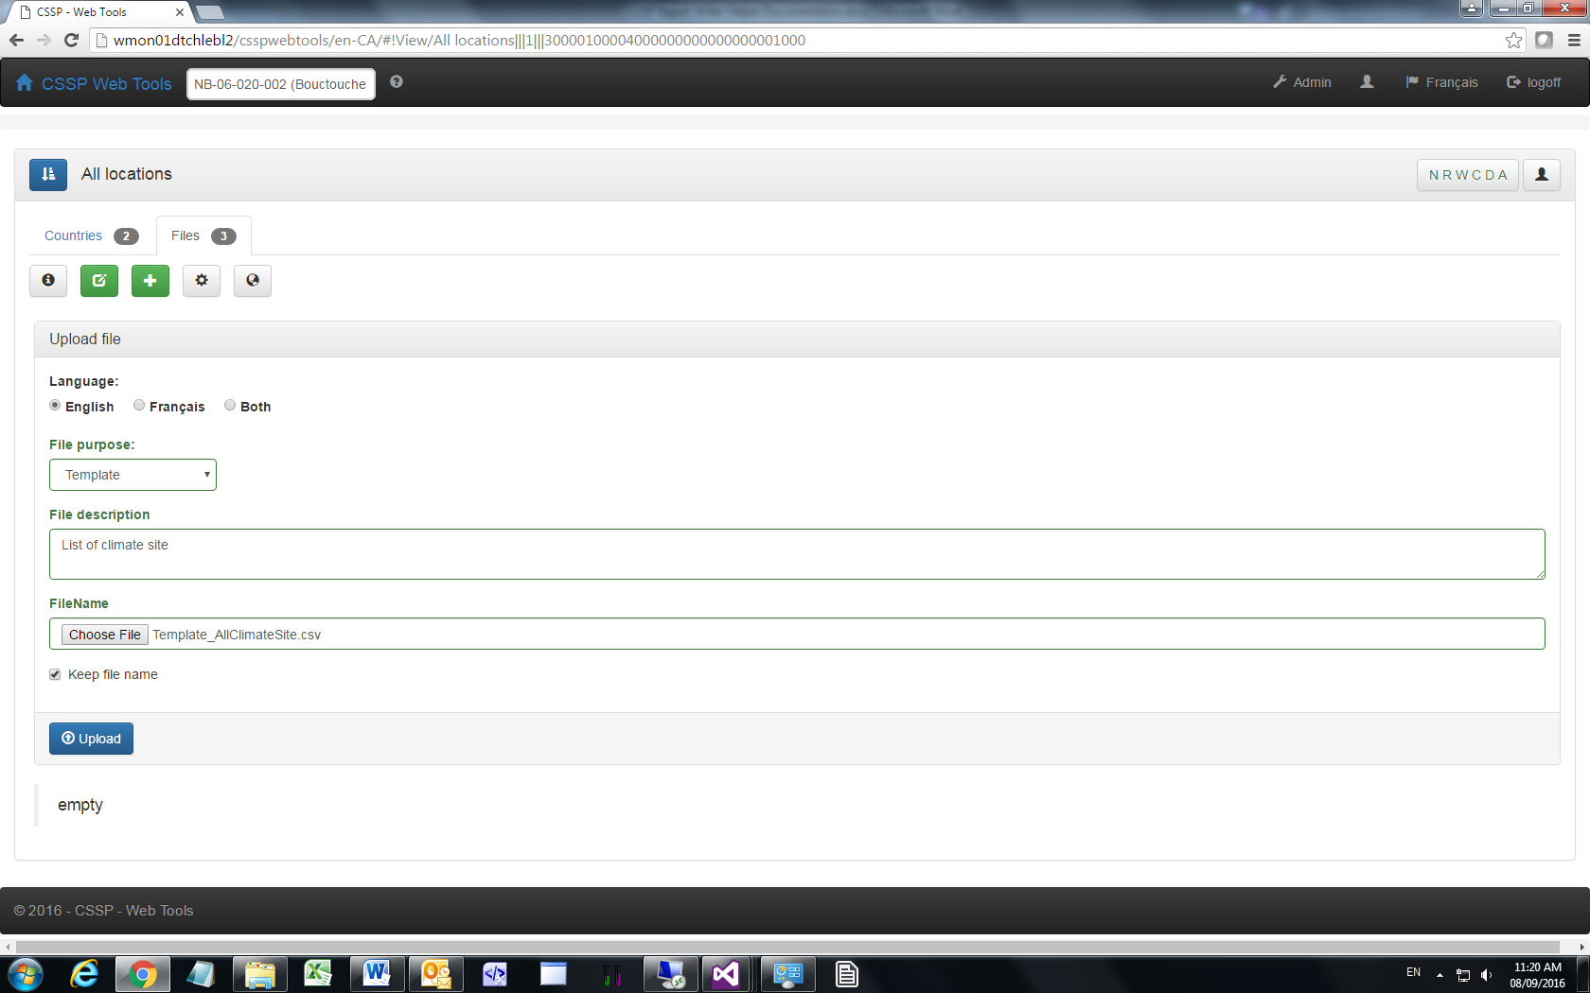

3.3.3 Fill in all the appropriate fields (Language, file purpose – template in this case, File description).

3.3.4 Select the file to upload (Note: has to be the same type). Next, click on the upload button.

3.3.5 To generate a report using the template you have just imported, click on the generate button . You can download and view the report by clicking on the edit button  and then on the download button  next to the file you want to view. You can save and view this document on your computer. You can also delete and edit these files.

3.5 Other types of special table

To come

1. **MAINTENANCE**

For any additional troubleshooting help (errors or bugs), please contact Charles LeBlanc (charles.leblanc2@canada.ca). For general questions, contact your local CSSP working group committee member.